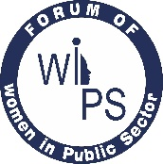

Forum OF WOMEN IN PUBLIC SECTOR
1
(Under the aegis of SCOPE)

WIPS Election of APEX: -

The Forum of WIPS has Functional Committees at the Apex and Four Regions, with tenure of two years. The elections of President, Vice President, General Secretary and Treasurer of the Apex and the President of all four regions were held on 16th February 2025 at New Delhi for the term 2025-2027. The members are elected through a well-defined election process and eligibility as per Charter of the Forum in presence of Observers (3) from SCOPE and two past CGB Members, appointed as Election Officers.

The election was conducted in the presence of election officers, Ms. Manjusha Bhatnagar, Former General Secretary, APEX & Ex Dir (HR&CC), Balmer Lawrie & Co. and Ms. Sumanlata Sharma, Former Treasurer, APEX & Chief Personal Manager, Coal India Ltd. and SCOPE nominees Mr. S A Khan, Lead Associate (Corp. Affairs), SCOPE, Ms. Hema Koul, Asst. Manager (Corp. Affairs), SCOPE & Ms. Garima Agrawal, Asstt. Manager (HR), SCOPE as observers.

Further the Regional Elections were also held in the month of March 2025 in the Regions in the presence of respective Election Officers & Apex Observers.

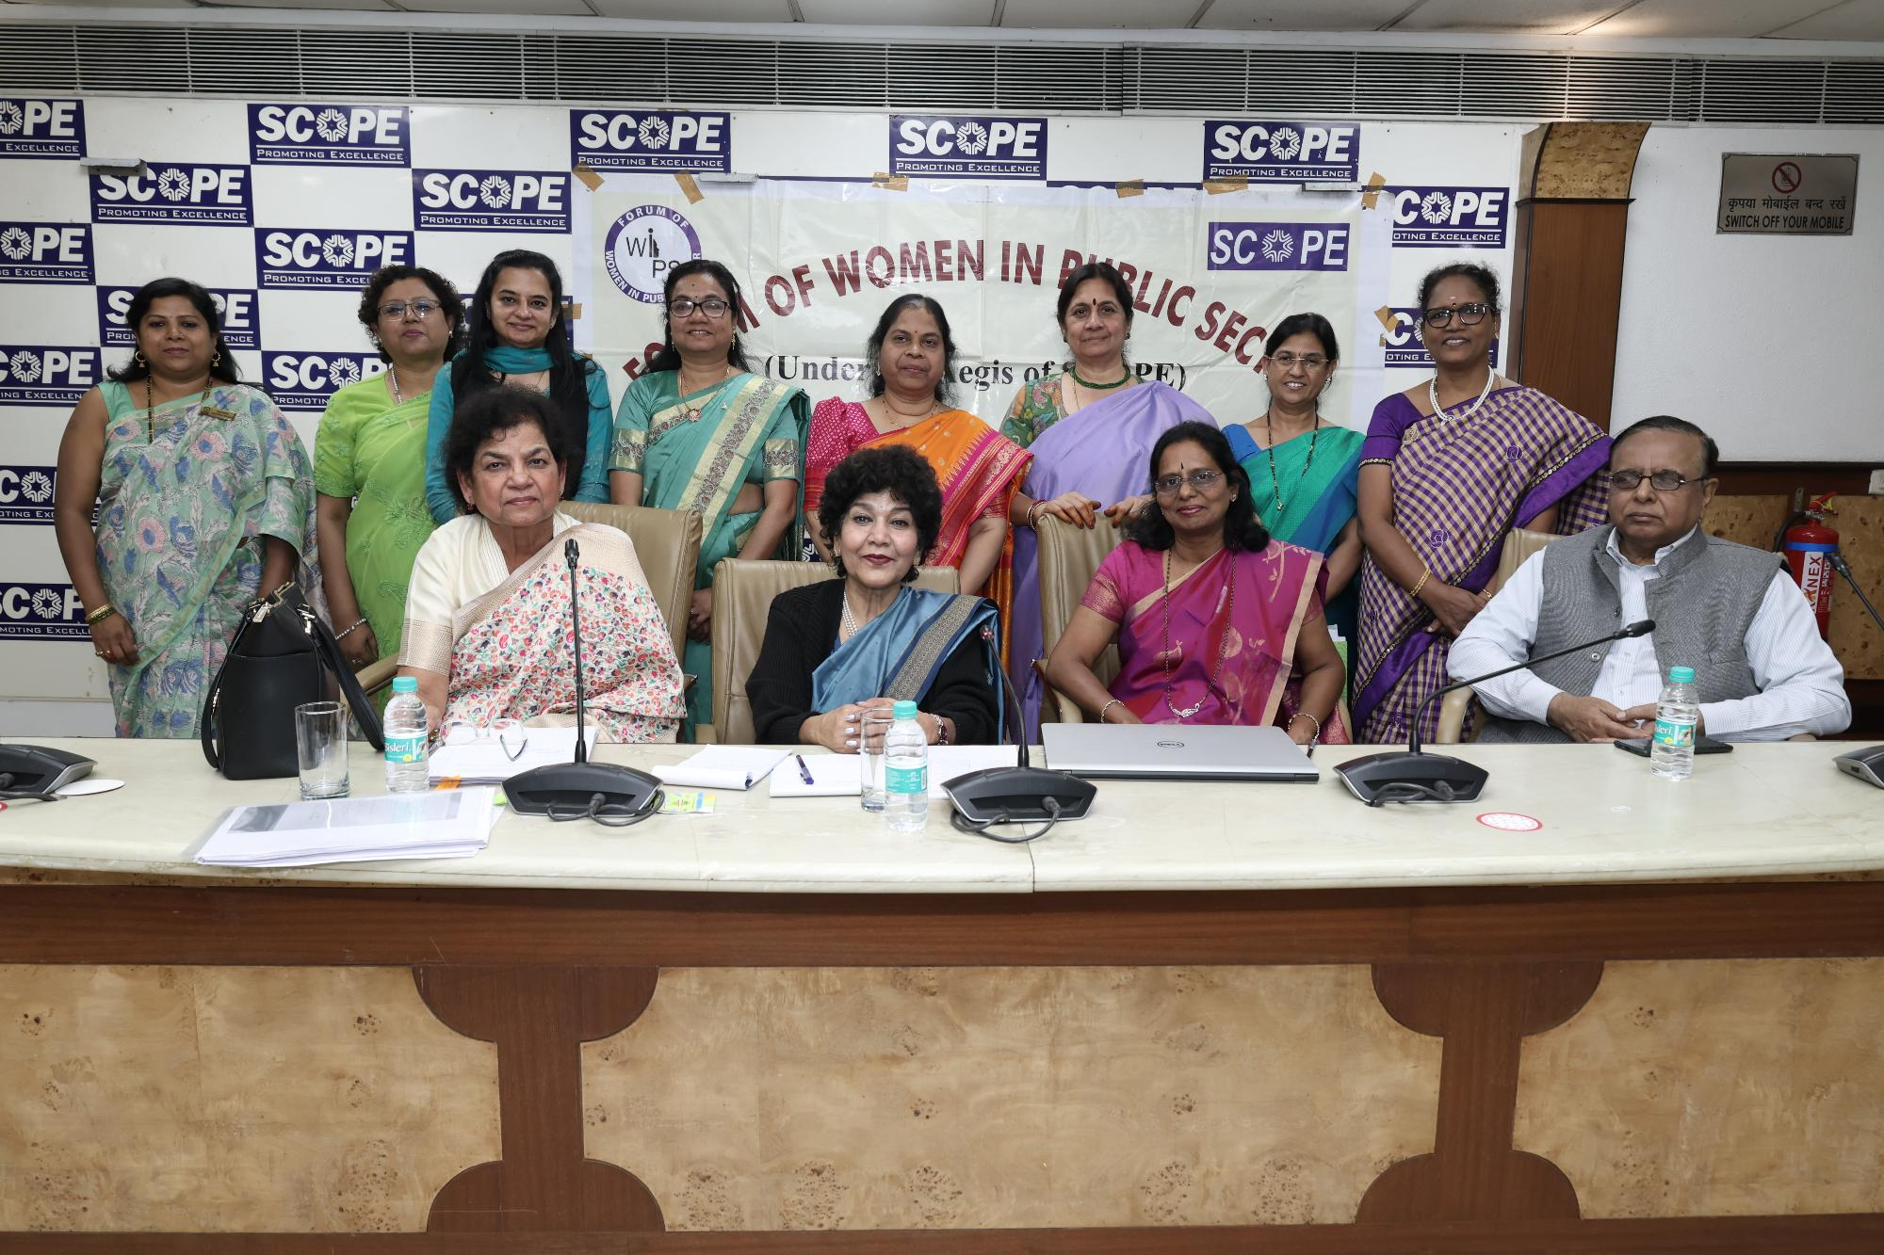
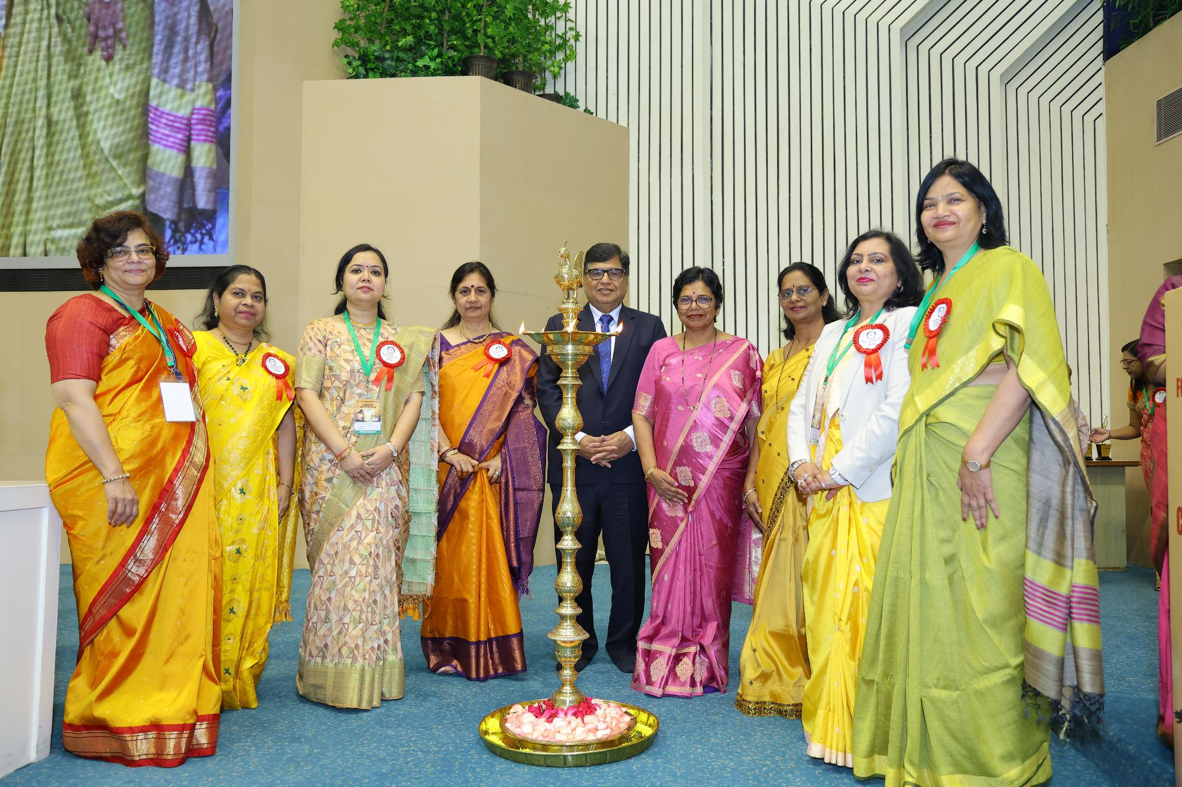

Forum of Women in Public Sector (WIPS), under the aegis of SCOPE, organized its 35th National Meet on the theme “Create Your Own Sunshine” on 17th & 18th February 2025 at Vigyan Bhawan, New Delhi.

The Chief Guest on the occasion was Ms Vijaya K. Rahatkar, Chairperson, National Commission for Women and Guest of Honour was Shri Atul Sobti, Director General, SCOPE & Member, Governing Body, ILO in the presence of Ms Varsha Raut, President WIPS-Apex and other office bearers of WIPS.

The meet brought together more than 500 participants, and during the event, awards were presented to exemplary women performers of PSUs. While addressing the gathering, the speakers emphasized that women in the Public Sector are vital to organisation’s performance and nation’s progress. The Meet was a successful one and was appreciated by all participants.

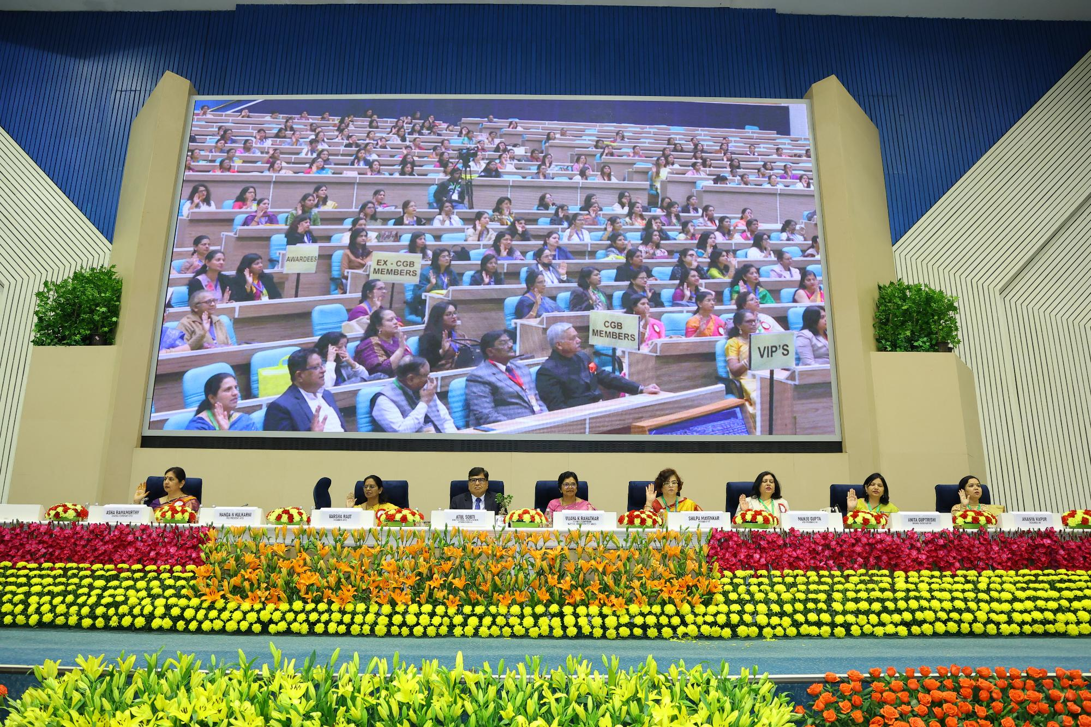

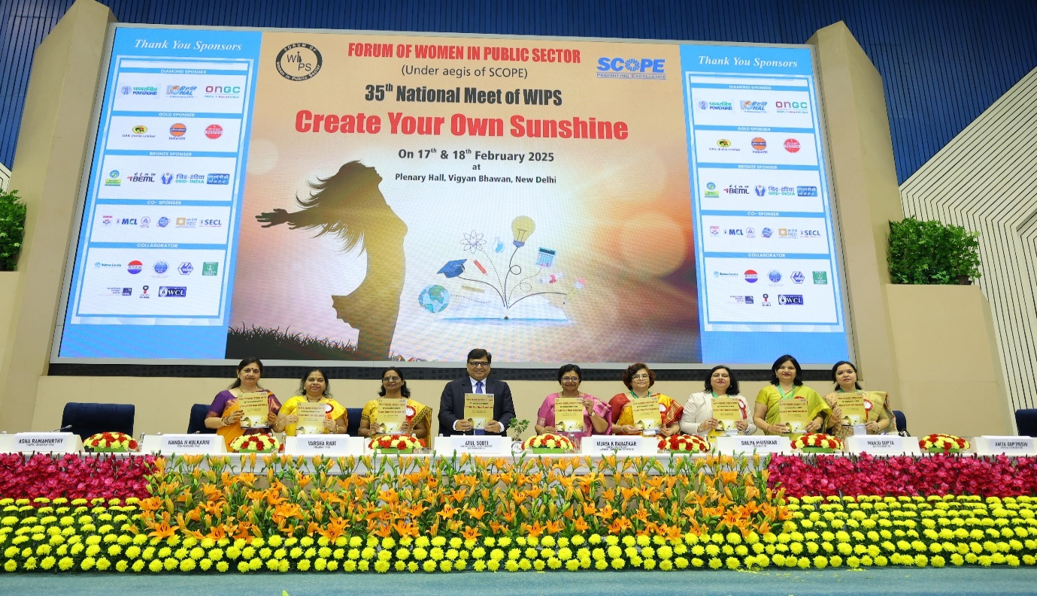

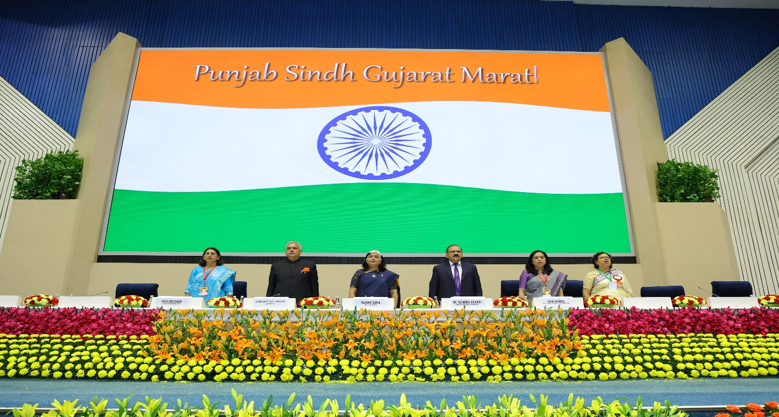

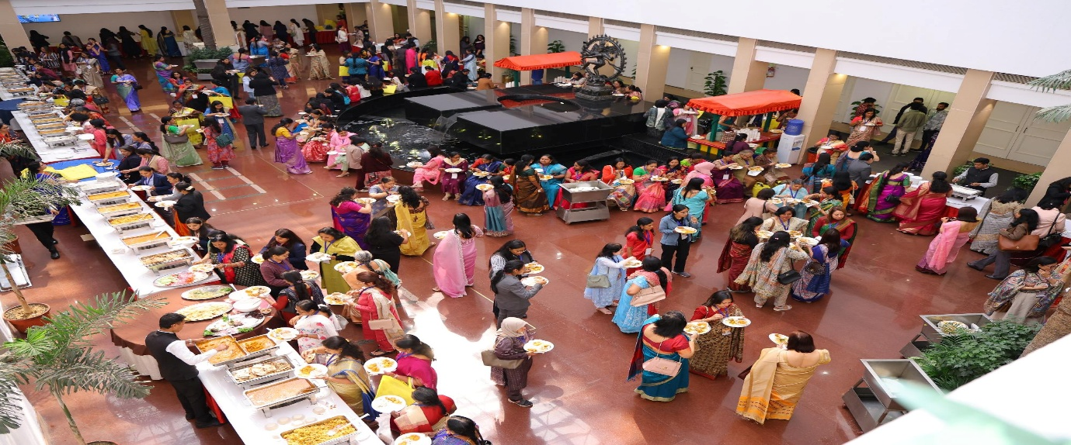

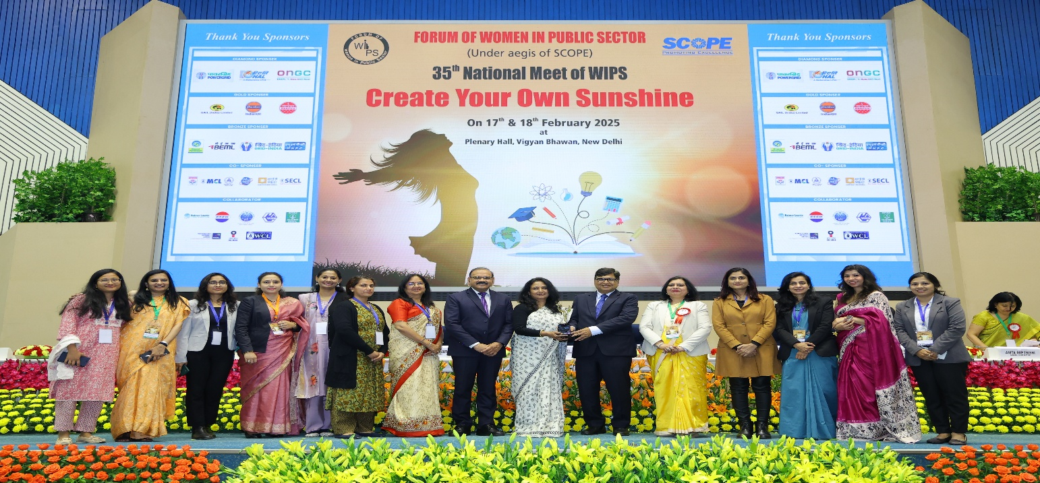

- WOMAN DAY Celebration

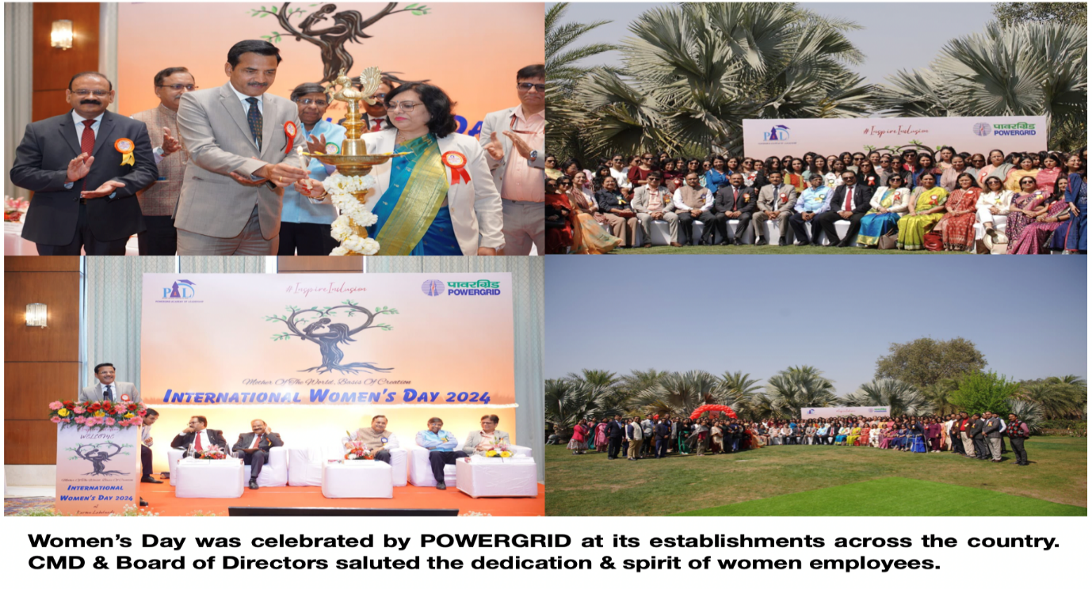

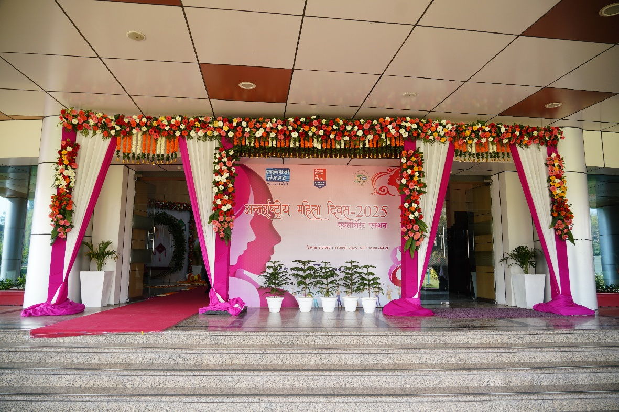

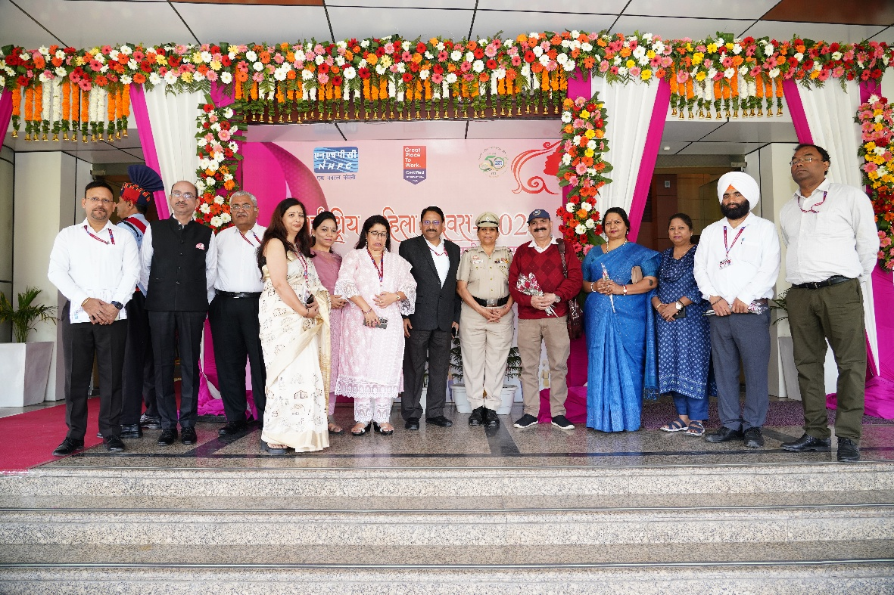

International Women’s Day Celebration

BHEL : Glimpses of International Women’s Say 2025 across BHEL Units

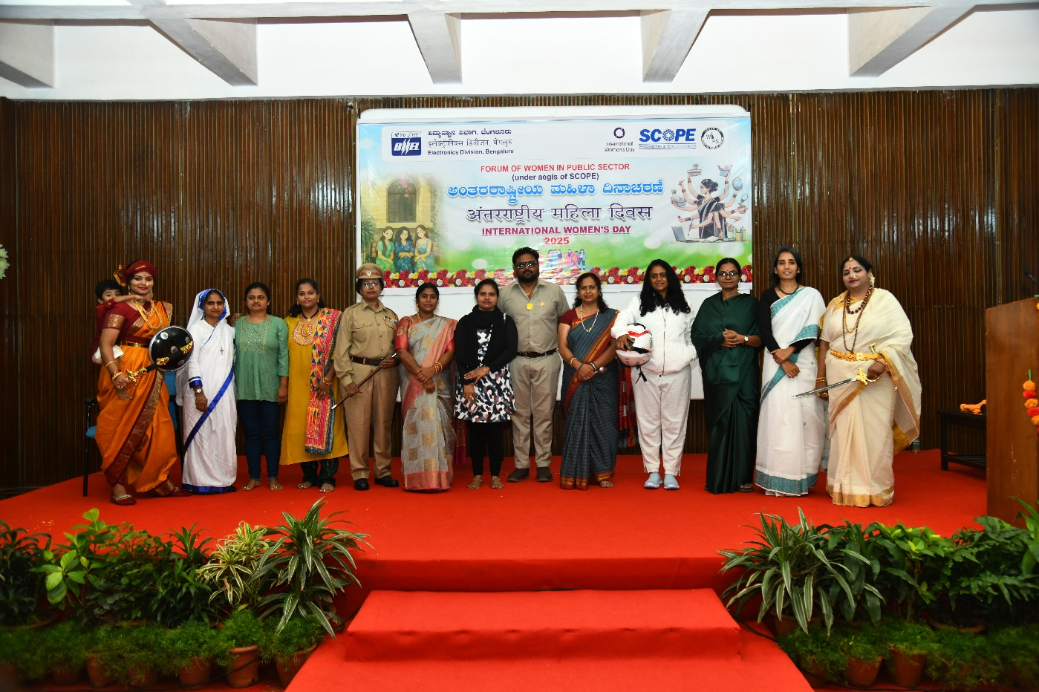

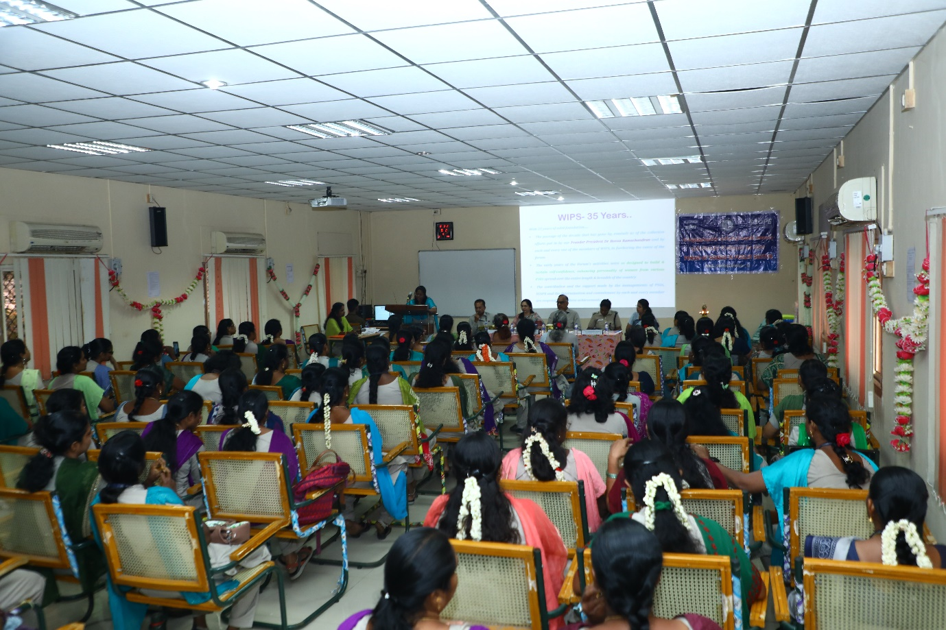
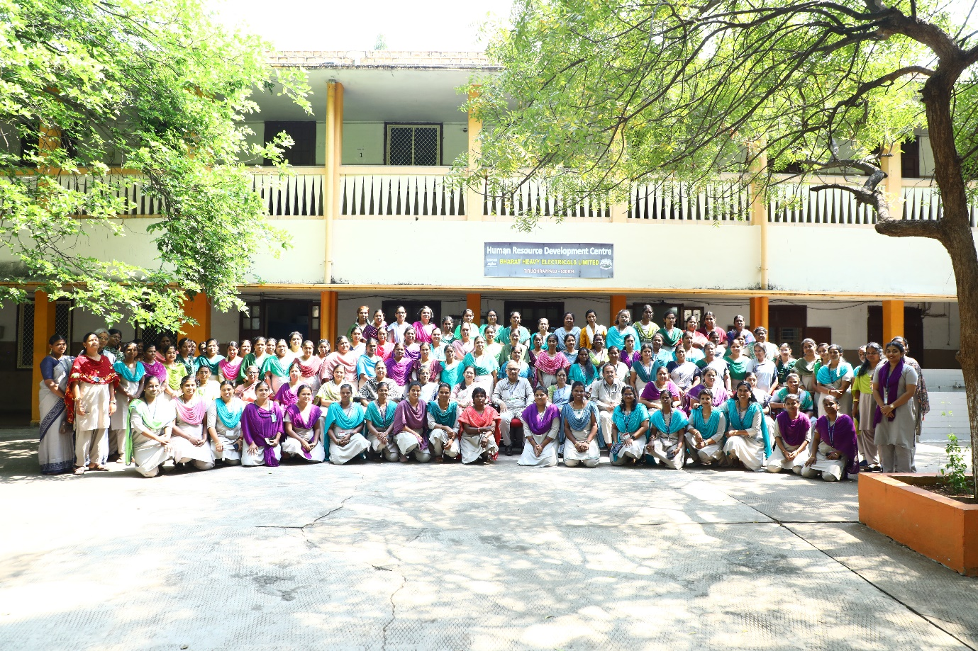

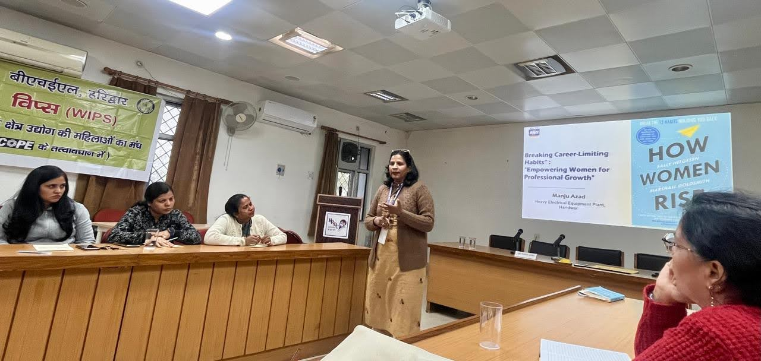

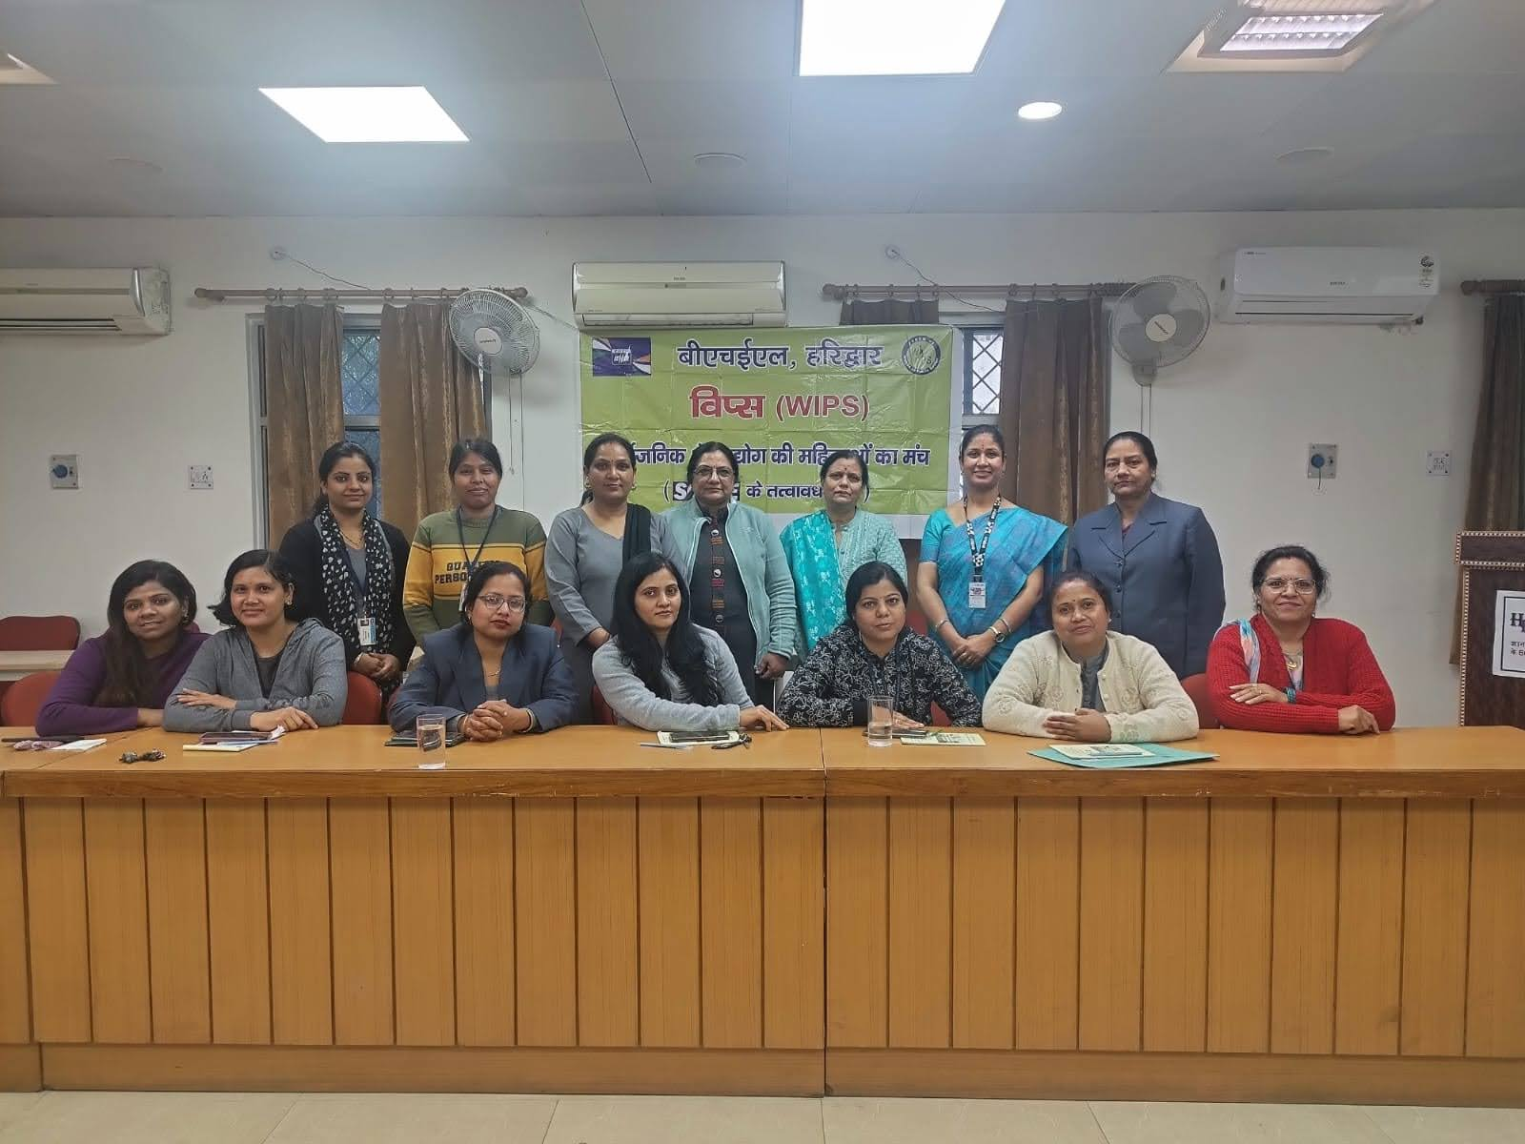
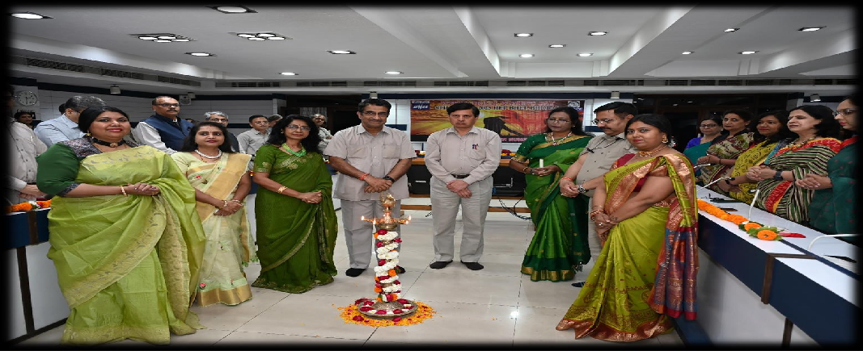

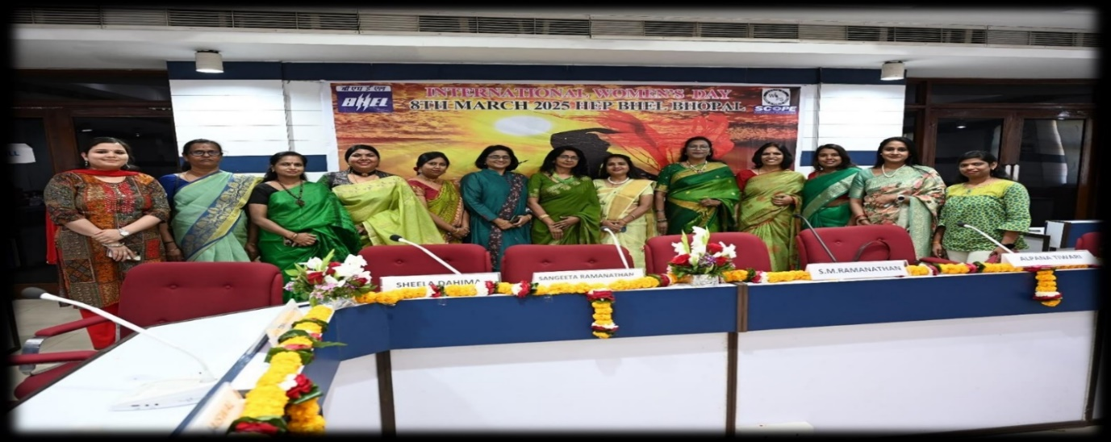

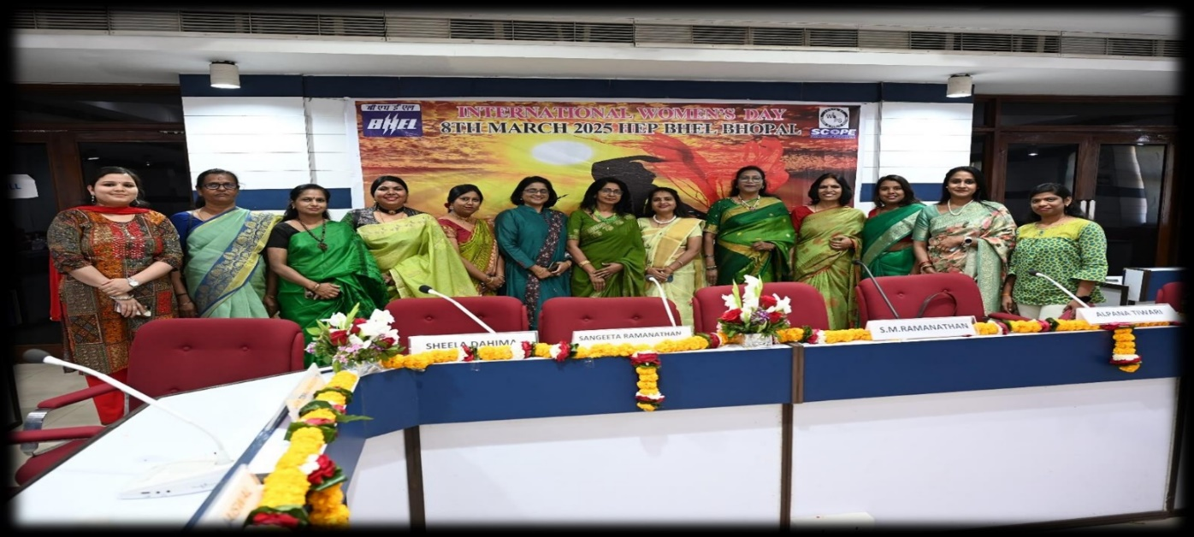
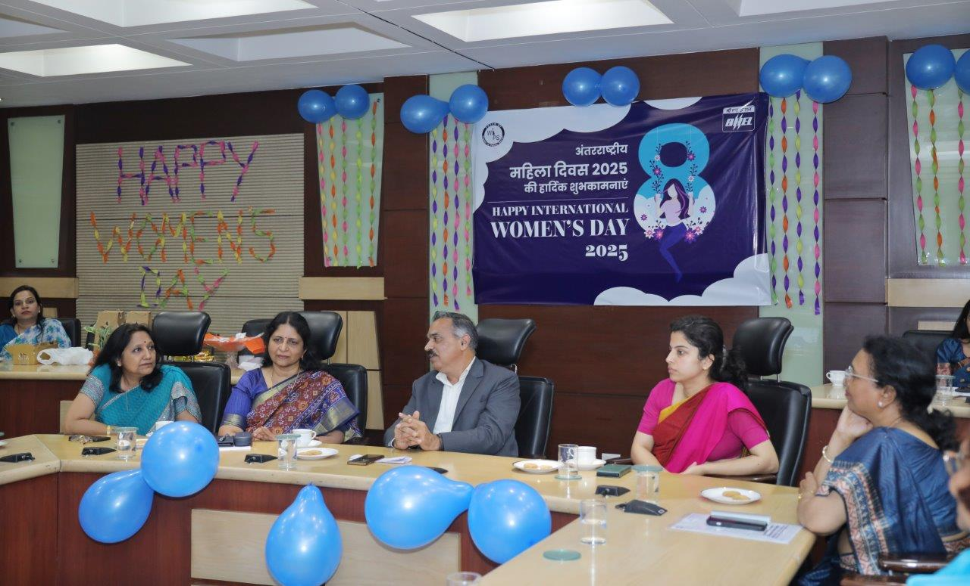

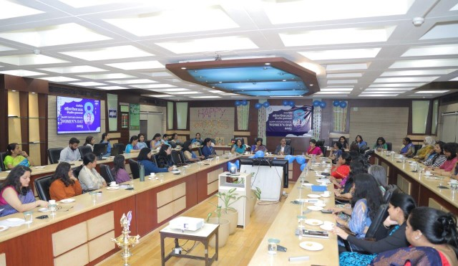

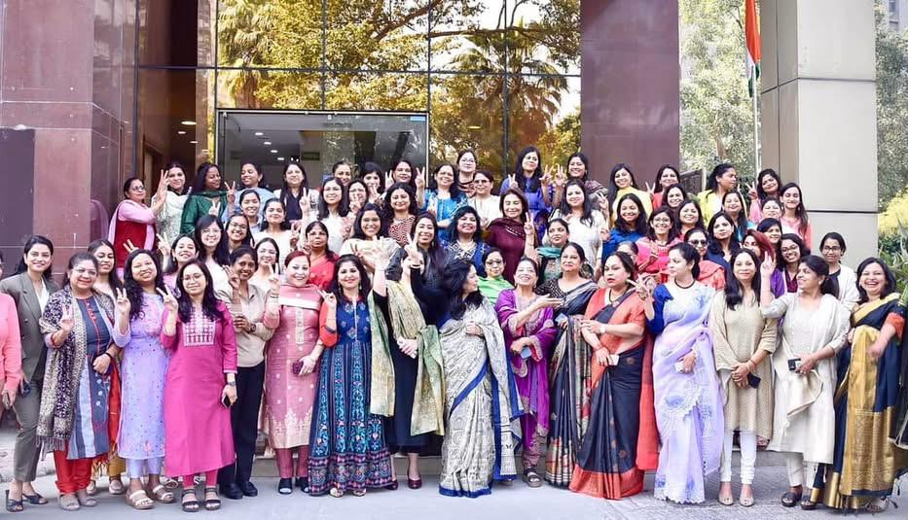
- Psu Connect Date: 09-03-25 ; Ministry of Power

NTPC
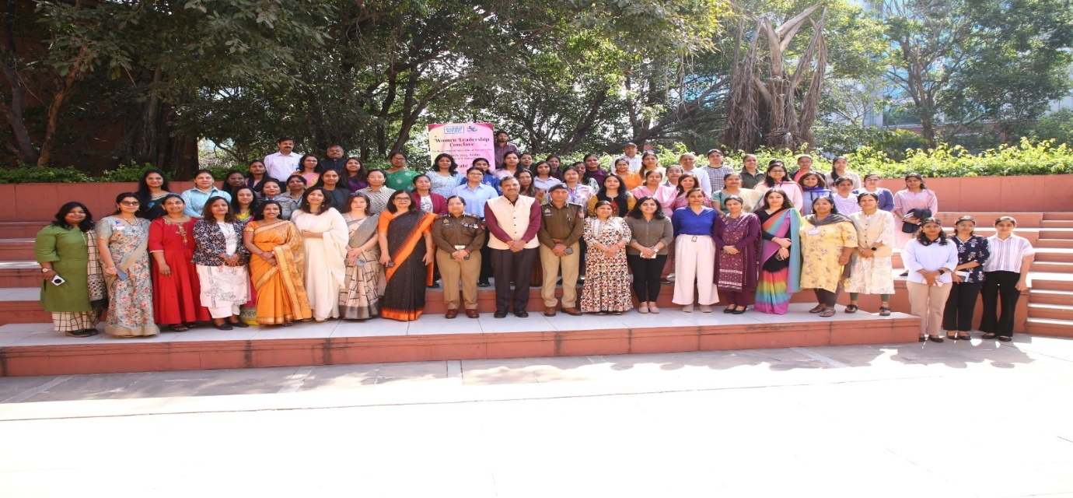

WIPS NR organized Training for Non Executives “Saksham”

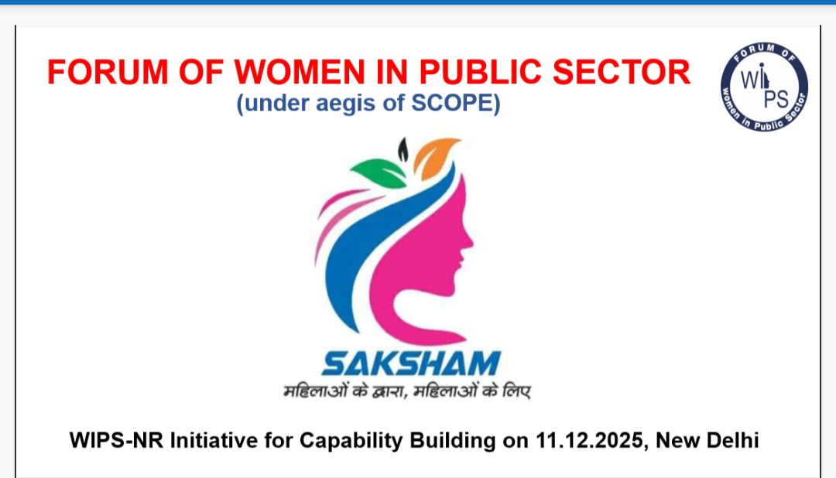

Session one : Financial Planning and Prudence Financial Management .

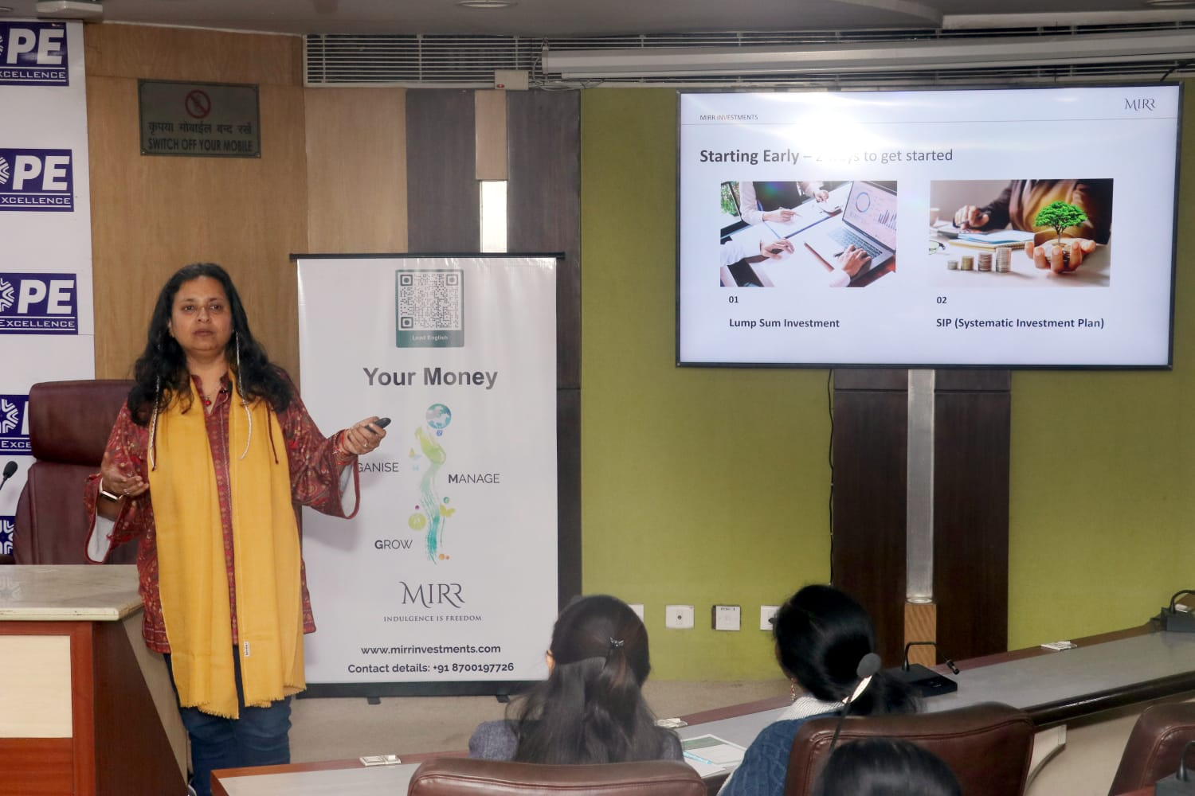

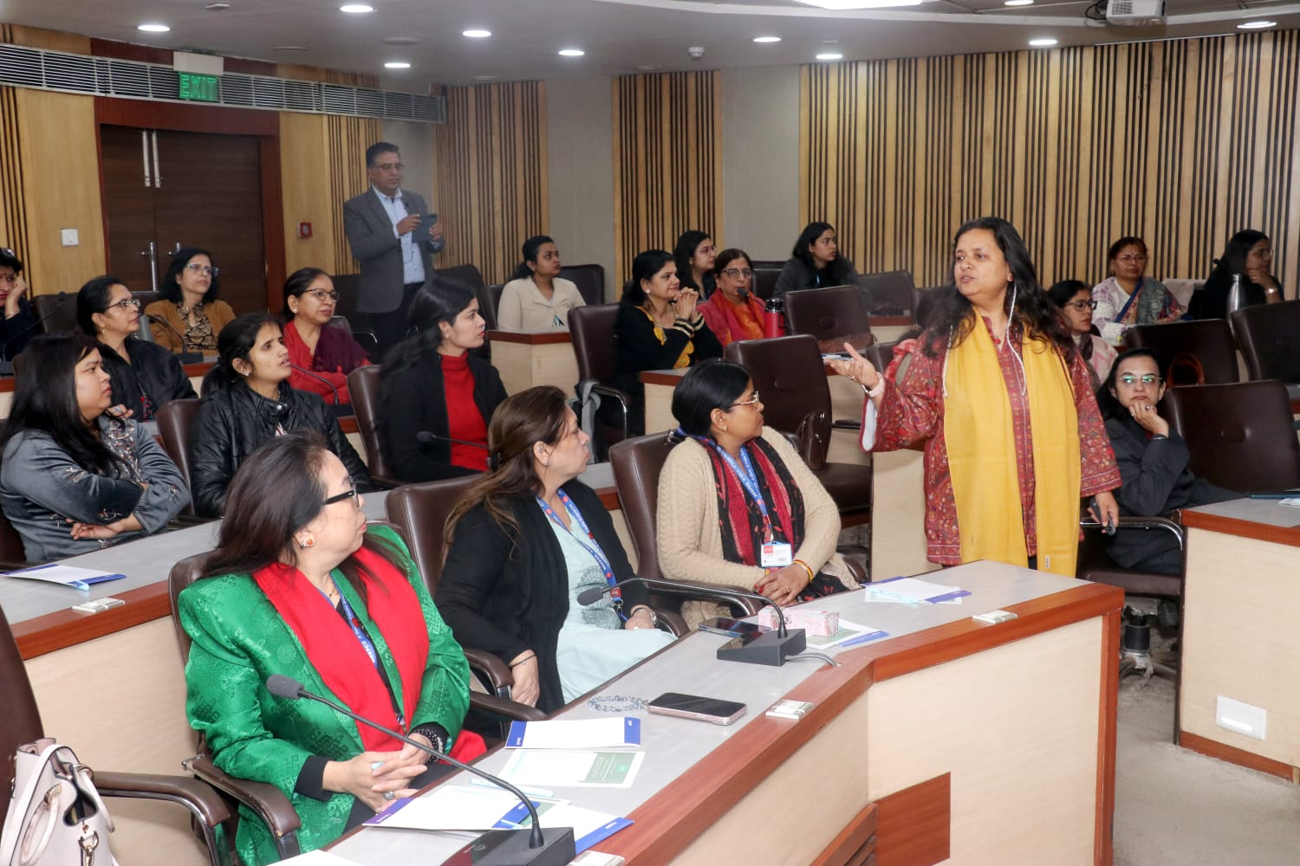

Session 2: Mental Emotional Well-Being

